**MARANATHA YOUTH WITH MISSION PROJECT**

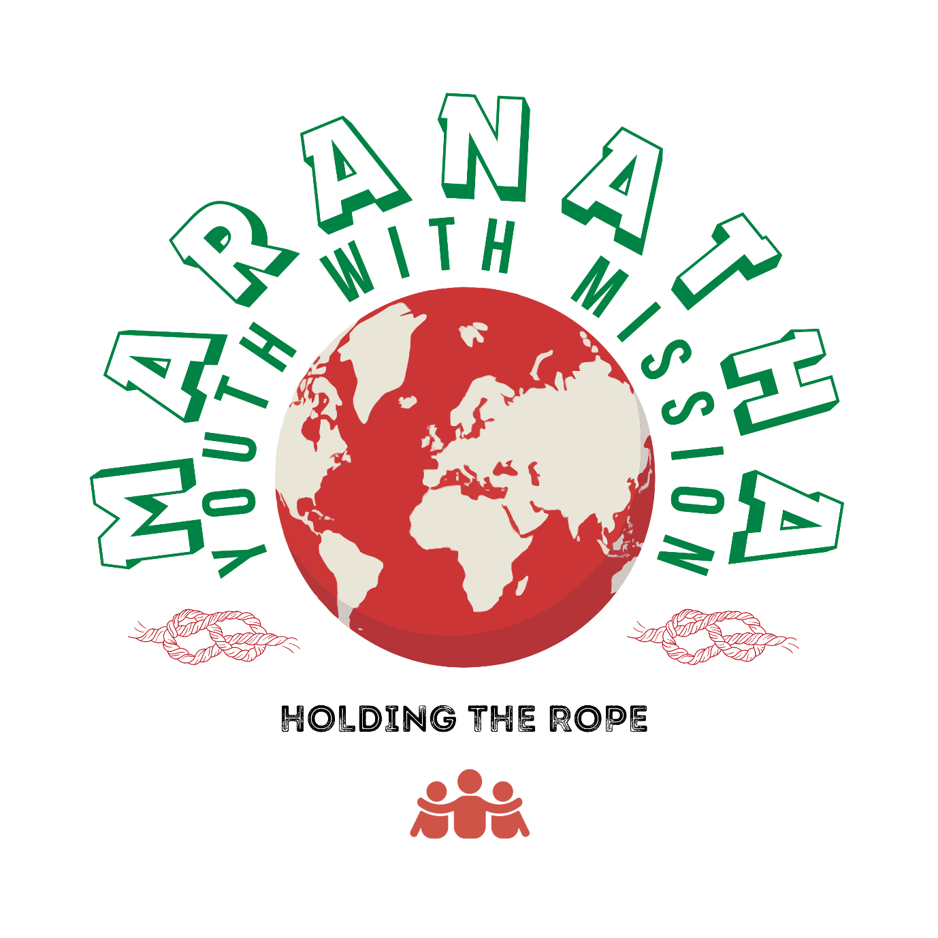

**INTRODUCTION**

Maranatha Youth with Mission is a project that was founded in February 2008 because of compassion and concern for the young generation in the community. It is currently registered with the National Department of Social Development (064-435-NPO) as a non-profit organization and thus operates for the benefit of the youth without any personal interest or benefit entertained. The project is based in the Greater Giyani Municipality of Limpopo Province in South Africa and intends to grow to be a national and international project.

**VISSION**

Striving for youth empowerment into independent, responsible adults and enhanced employability.

**MISSION**

The youth project is committed to the empowerment of the young generation with skills and knowledge in the social, educational, psychological and spiritual dimensions and rendering possible assistance to the less advantaged in the community through outreach programs.

**OBJECTIVES**

The project aims to achieve the following objectives:

* To empower youth with skills and knowledge for relevance in the labor market.
* To provide youth with relevant information regarding making choices and becoming responsible adults.
* To reach out to the less advantaged in the community and provide assistance in whatever way possible.

**CONCEPTUAL DEFINITIONS**

MARANATHA is a Hebrew word meaning” Jesus is coming soon.”

YOUTH means a young individual who is not yet an adult. In this context it includes young persons ranging between the age of six (6) and thirty-five (35), and not yet married.

**DESCRIPTION OF THE LOGO**

The RED BALL resembles the whole world. Red resembles a pit/danger zone wherein young people intentionally or unintentionally find themselves. This may be a pit/danger zone of drug abuse, alcoholism, poverty, emotional trauma, and spiritual or social deprivation.

The GREEN LETTERS “MARANATHA YOUTH WITH MISSION” is the name of the youth project.

The RED ROPES on the bottom sides of the name resemble the effort by which Maranatha youth members must assist other young people to come out of the pit/danger zone in which they find themselves.

The three RED PEOPLE at the bottom of the logo hugging each other resemble the youth who are interested in joining Maranatha with the aim of helping others.

The motto “**HOLDING THE ROPE**” written in black means that the youth in Maranatha use a rope to rescue the youth in the pit/danger zone by pulling the rope out as the victims hold it. This rope is represented by a range of activities that aim to achieve the mission as outlined below:-

**PROJECT ACTIVITIES**

**a. Psychotherapy/Social C**o**unseling**

**Objective:** To promote emotional healing for individuals and empower them with skills to make informed choices to become responsible adults.

**Description:** It is a means of addressing an individual’s social, psychological, and emotional challenges encountered in a lifetime with different skills and techniques. Challenges may include trauma, loss, deprivation, and abuse. Referral to access the service may be by self, relative, community member, or professional. The service may be on an individual, group, or family basis, depending on the need. Sessions take place per appointment to enable the counselor to reserve time for this and will last for as long as it is necessary.

**b. Educational support**

**Objective:** To equip youth with skills that will pave their way towards the employment world.

**Description:** Young people are exposed to life skills in general, including academic and vocational skills. Skills such as computer literacy and fashion design are also considered. Life orientation skills like how to deal with physical, emotional, and social changes in adolescence are dealt with. Consideration is also directed towards the making of choices for careers, friends, marriage partners, and lifestyles about the relevance of age groups. Education about health problems such as HIV and AIDS, sexually transmitted diseases, cholera, bilharzia, TB, and others is given. Learners re assisted in different learning areas where they have trouble in different grades. Group discussions are promoted and facilitated. Financial assistance is offered to individual members when necessary and where possible.

**c. Birthday celebration**

**Objective:** To motivate young people towards good behavior and to encourage striving for excellence.

**Description:** On a semester basis, birthdays for members are acknowledged by organizing a birthday celebration event for those whose birth month falls within a given semester. Motivational speakers are invited to come and encourage them. Tokens of appreciation and award certificates are handed over to deserving individuals considering outstanding behavior and performance.

**d. Sports and Culture**

**Objective:** To channel youth’s energy towards constructive and socially acceptable behavior, thus denying them time to engage in drugs and other habit-forming substances. To sustain and restore the heritage of diverse cultures.

**Description:** Youth are exposed to a range of sporting and cultural activities according to the area of interest, e.g., soccer, netball, swimming, cricket, dancing, etc., and from the cultural areas are Xibelani, Makhwaya, Xigombela, Xikhaba, etc. Traditional attire designing is also a point of focus. Traditional dishes prepared during events and recipes communicated to other young people.

**e. Agricultural activities**

**Objective:** To cater for the poor and needy in the community and other charity organizations and to act as a beef-up financial resource for the organization.

**Description:** We intend to cultivate vegetable crops and do chicken farming as soon as we access space for such. Harvests will be sold, and some will be donated to the poor in the community.

**f. Outreach and charity**

**Objective:** To assist with the alleviation of poverty in the poverty-stricken community.

**Description:** Resourcing from funding, donations, fundraising, and agricultural crops harvested, the poor in the community will be identified through liaison with relevant local authorities, visited, and surroundings cleaned, and offered basic food parcels.

**g. Pastoral Care**

**Objective:** To maintain discipline and cater for the spiritual needs of individuals.

**Description:** A code of conduct has been drawn up. If any member breaches the code of conduct, disciplinary action will be taken for the member. Spiritual sermons will be conducted, and people may voluntarily receive salvation without any form of coercion.

**HOW TO BECOME A MEMBER?**

All young people, irrespective of gender, color, creed, socio-economic status, cultural and religious background, and ranging between the age of zero (0) and twenty (20), who are not yet married and are interested, are welcome to make an application by completing the relevant forms. In early childhood, parents are allowed to join on their children’s behalf, and the application will be revised when they are grown enough to make their own decision to remain members. Forms are returned with a joining fee of R20 (Twenty Rand) and a subsequent monthly contribution of Five Rand (R5) from the month following the one on which membership was approved. The applicant is notified via an SMS if the application has been approved.

**WHEN IS THE MEMBERSHIP TERMINATED?**

For any unacceptable behavior resulting in a breach of code conduct by a member, Disciplinary action will be taken. If such behavior continues, then membership will be terminated for the individual.

Members who get married automatically terminate membership and may voluntarily become supporters of the project.

Members who fall pregnant or impregnate other members/non-members illegitimately will be suspended, and their case will be thoroughly checked by the disciplinary committee, which will eventually make a final decision on whether to terminate or reinstate the membership of such an individual.

For more detailed information, please do not hesitate to contact the following individuals:

Dr Rikhotso Tinyiko Nelly @ Cell: 073 3926 743 (Founder)

Mrs. Nukeri Israel Rachel @ Cell: 083 5926 132 (Director-Marketing department)

Mr. Muthemba Neo Gasper Cell: 073 6503 780 (Chairperson-Marketing department)

Mr. Anel Khosa 0608421356 (Vice-Chairperson-Marketing department)

OR

Write to: MARANATHA YOUTH WITH MISSION PROJECT

P.O.BOX 973

GIYANI

0826

SOUTH AFRIKA

OR

E-mail to: info@maranathayouth.org.za

Thank you for taking the time to read through this information booklet.

God bless you.